PRESIDENTIAL
SCAVENGER HUNT
How to participate:
Start by looking at the images carefully, and then read the clues next to each for hints as to where to start. As you read each clue, think about whether it points you in the direction of a particular
exhibition within the Museum’s main building. The clues help you find the object within an exhibition; maybe you will recognize the image as you walk around and explore.
Hint: to answer some of the questions, read the object labels.

DISCOVER. LOOK. LEARN.

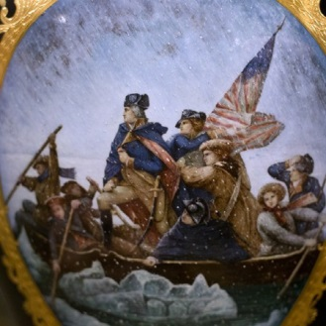
- I can be found among some pretty big things and painted on something fragile.
  - You may recognize this famous image but I’m much smaller and not on canvas.
  - I’m depicted in a famous event that took place in New Jersey on the Delaware River.
  - I would become America’s first President.
Who am I? Which exhibit am I in? What am I?

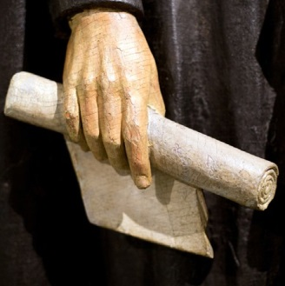
- I’m made out of wood, the tallest object in a room of big things; just as tall as I was in real life.
  - I’m holding a document; could it be the Emancipation Proclamation?
  - I’m a famous Illinois resident and on the penny…and I visited New Jersey.
  - I was the 16th President of the United States.
Who am I? Which exhibit am I in? What am I?

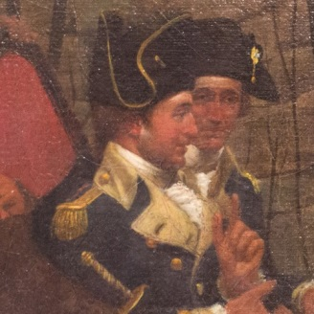
- If you look closely, you might see me as you reach the top of a flight of stairs.
  - This is an unusual image of me – one most people haven’t seen.
  - I’m part of a story that took place in Morristown, New Jersey.
  - I spent a very cold winter in Morristown, NJ during the Revolutionary War. Who am I? Which exhibit am I in? What am I?

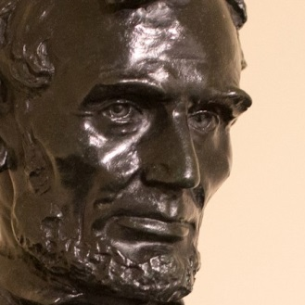
- I can be found among some interesting American perspectives.
  - I’m a much smaller version of a monumental sculpture in Washington, D.C.
  - I’m cast in bronze and placed on a marble pedestal.
  - Some people think I look stern or angry, but as President I was facing some serious issues. Who am I? Which exhibit am I in? What am I?

For a complete list of the Museum’s exhibitions, educational programs, events, and planetarium shows, please visit: WWW.STATEMUSEUM.NJ.GOV
New Jersey State Museum
Chris Christie, Governor
Kim Guadagno, Lt. Governor/Secretary of State Margaret O’Reilly, Executive Director

PRESIDENTIAL SCAVENGER HUNT

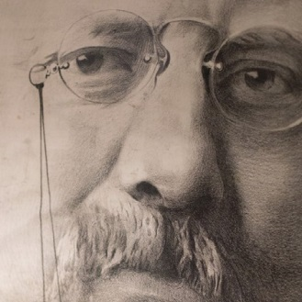
- History has said that I was larger than life; I certainly had some pretty big ideas.
    - I spent several summers in Maplewood, New Jersey.
    - I shared a last name with another President who was also known as FDR.
    - I was the 26th President and instrumental in expanding the Nationals Park system. Who am I? Which exhibit am I in? What am I?

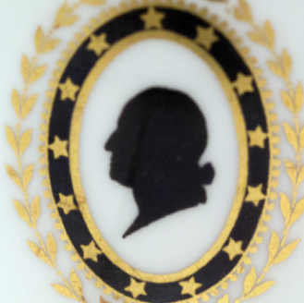
- I am surrounded by images that remember the Revolution.
  - This type of image is called a silhouette and is a profile view.
  - My profile is almost as recognizable as the more detailed paintings you’ve already seen.
  - Each star represents one of the original 13 colonies; the third star represents New Jersey. Who am I? Which exhibit am I in? What am I?

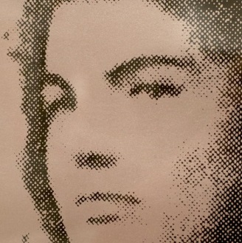
- I was not president, but my husband, John, was.
    - I was known as a fashion and cultural icon, which is probably why I was chosen for this screenprint.
    - My purple screen makes my American perspective pop in a room of white.
    - My husband’s family is well known in politics-his father, brothers, and others all held various important positions which made my last name known world-wide.
Who am I? Which exhibit am I in? What am I?

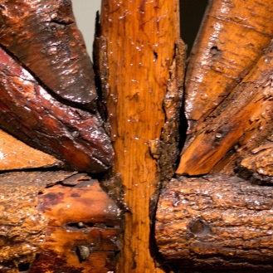
- I am the 28th President of the United States and my big object is located near another president’s memorabilia.
  - I was President during World War I and used my 14 Points idea as the basis for negotiating the peace treaty that ended the war. I thought the ideas expressed in the 14 points would help prevent future wars.
  - I was Govenor of New Jersey before being elected president.
  - Although I grew up in the South, I attended Princeton University and after that entered NJ politics.
Who am I? Which exhibit am I in? What am I?

