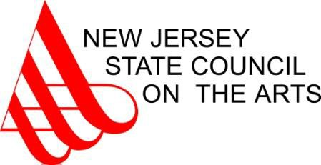

2016 Individual Artist Fellowship Awards

Painting

Shoshanna Weinberger | Newark | Essex | $12,000
Theresa Pfarr | Plainsboro | Middlesex | $12,000
Ken Weathersby | Montclair | Essex | $ 8,000
Livio Saganic | New Vernon | Morris | $ 8,000
Julia Stein | Princeton | Mercer | $ 8,000
Jason Bereswill | Lambertville | Hunterdon | $ 8,000

Works on Paper

Holli Schorno | Newark | Essex | $12,000
Anonda Bell | Montclair | Essex | $12,000
J.C. Lenochan | Orange | Essex | $12,000
Nancy Cohen | Jersey City | Hudson | $ 8,000
Karen Guancione | Belleville | Essex | $ 8,000
Ellen Singer | Jersey City | Hudson | $ 8,000
Harry Naar | Lawrenceville | Mercer | $ 8,000
Kay Kenny | Orange | Essex | $ 8,000

Prose

John Parras | New Milford | Bergen | $ 8,000
Noreen McAuliffe | Princeton | Mercer | $ 8,000
Bill Mesce Jr. | Linden | Union | $ 8,000

Interdisciplinary Performance  Melanie Stewart | Pilesgrove | Salem | $12,000
James Scruggs | Jersey City | Hudson | $ 8,000
Laura Quattrocchi | Jersey City | Hudson | $ 8,000

Media

Beth Horowitz West Orange Essex $ 8,000

