Total Dissolved Solids and Chloride Increases

Long term water quality monitoring data show national and state trends of increasing Total Dissolved Solids (TDS) and dissolved chloride concentrations in surface water. Elevated TDS and chloride directly impact aquatic life (including macroinvertebrates, fish and amphibians) and human health, while chloride can also indirectly affect human health by increasing corrosivity and the potential for increased dissolved metals in drinking water.

USGS (Mullaney et al, 2009) conducted a study of chloride in ground water and surface water by analyzing data collected from 1991-2004 in the northern United States. Surface water quality data from 15 of 100 sites, collected primarily in winter, had chloride concentrations higher than the U.S. Environmental Protection Agency (USEPA) recommended aquatic life chronic criterion of 230 mg/L. Upward trends in chloride loads were apparent in several urban basins. Sources of the increased chloride include increases in paved areas and the subsequent road salt usage, increases in wastewater and septic system discharges, recycling of chloride from drinking water, and leachate from landfills and salt storage areas.

In a study of 30 monitoring stations in the northern U.S. by Corsi et al (2015), concentrations of chloride increased substantially over time, with average concentrations approximately doubling from 1990-2011. Long term data showed increasing concentrations in all seasons in most streams, while maximum chloride concentrations occurred during the winter. This suggests that chloride was stored in the soil or shallow ground water system during the winter and gradually discharged in baseflow throughout the year. In addition, increasing chloride trends were observed in watersheds dominated by different land uses, although the magnitude of chloride concentrations, as well as the rate of increase, rose with the amount of impervious land cover in the watershed.

Robinson et al (1996) evaluated water quality trends during water years 1975-1986 at 60 stream monitoring stations in New Jersey for statistical association with drainage basin characteristics, including dominant land use, population, wastewater discharges, road salting, fertilizer application, and estimates of soil erosion and irrigated land. Among the correlations observed in the study, it was found that upward trends in specific conductance, sodium and chloride were statistically associated with the amount of road salt applications. In addition, drainage basin size was correlated with upward trends in specific conductance and dissolved chloride, which corresponds with the conservative behavior of chloride in streams that results in larger concentrations in a downstream direction. While wastewater discharges and fertilizer use are also sources of ions, the increased use of road salt during the study period suggests that road salting appears to be a significant source of these dissolved ions.

Hickman and Gray (2010) evaluated water quality trends at 70 long-term monitoring sites on New Jersey streams over a ten-year period (1998-2007). Using a statistical method that corrected for flow variation over time, increasing trends in TDS were identified at 24 stations throughout the water regions of the state, while no stations had decreasing TDS trends. When compared to two previous studies that used the same methods, trends of increasing concentrations of TDS were exhibited in 24% of the stations analyzed during water years 1980-1986 (Hay and Campbell, 1990), 26% of the stations analyzed during water years 1986-1995 (Hickman and Barringer, 1999), and 34% of stations analyzed during water years 1998-2007 (Hickman and Gray, 2010).

In a study by Hickman and Hirsh (2017), trend tests were conducted for water years 1980–2011 using two methods to identify trends: Weighted Regressions on Time, Discharge, and Season (WRTDS) models and seasonal rank-sum tests. Results showed upward trends using one or both statistical methods for all 4 stations evaluated for specific conductance, chloride and TDS.

In contrast to the aforementioned studies, Heckathorn and Deetz (2012) used a randomly selected probabilistic network of over 370 sites in New Jersey to evaluate statewide trends rather than trends by individual stations. The report statistically evaluated year-round data from 1998-2009 of TDS as well as January to March concentrations of dissolved chloride, when road salt application is likely to occur. The analysis showed median concentrations of TDS and chlorides increased statewide during the assessment period, while background stations (relatively unaffected by human activity) exhibited no significant variations of median concentrations during the study period.

A Towson University/USGS study of 93 sites (Moore et. al., 2020) (including one site in New Jersey) used continuous specific conductance data to model chloride concentrations and found a correlation between median chloride concentration and average application rates of road salt. When analyzing the data grouped by region (Southeast, Mid-Atlantic and New England), they found that sites in the Southeast, where very little road salt is used, had no exceedances of chloride standards, and there was no seasonal variability or increasing trend in chloride concentrations. In contrast, most sites in the Mid-Atlantic and New England regions frequently exceeded both chronic and acute chloride standards, these exceedances were mostly in the winter, and concentrations trended upwards over time. Furthermore, at sites in watersheds with more than 10% impervious surface and median year-round chloride concentrations more than 150 mg/L, exceedances were not only common in winter, but regularly extended into non-winter months.

Sources

TDS and chloride increases have been associated with runoff from urban and agricultural areas, especially runoff of salt used to control ice on roadways, as well as discharges from wastewater treatment facilities and septic systems. Winter storm-related data supports a correlation between road salting and increased TDS and chloride levels in the water column. These growing trends correspond to the rising use of salt for road deicing in the United States, which has increased from about 8 million metric tons in 1975 to 23 million metric tons in 2020, .

A USEPA review of “Environmental Effects from Deicing Compounds” (1973) summarized studies that measured chlorides ranging from 1,130 to 25,100 mg/L in highway snowmelt runoff, while studies of stream water quality in winter showed frequent chloride concentrations over 2,000 mg/L.

A 1988 USGS study (Harned, 1988) that measured contaminants from highway runoff found that specific conductance and chloride (as well as alkalinity, calcium, sodium, and metals) were greater at the highway stations than in the undeveloped basins. Concentrations of these pollutants was highest during the winter months. It was estimated that highway deicing and sanding supplied 67% of the annual TDS loads from highway runoff.

The “National Management Measures Guidance to Control Nonpoint Source Pollution from Urban Areas” (USEPA, 2005), identified deicing salts as the primary source of chloride from highway runoff. Studies of snowmelt revealed that chloride, conductivity and TDS increased rapidly in highway runoff because of initial deicing salt applications at each site. Conductivity trends were strongly correlated with chloride trends. In addition, concentrations of metals in highway snowmelt (lead, copper, cadmium, zinc, and cyanide) were orders of magnitude higher than those measured in the control site.

NJDEP Analysis of TDS and Chloride Trends

Data from the DEP’s year-round Ambient Surface Water Quality Monitoring Network (ASWQM) show increasing trends in median concentrations of dissolved chloride (Figure 4.1) and TDS (Figure 4.2). There is also evidence that the number of samples which exceed New Jersey’s surface water quality standards (SWQS) (N.J.A.C. 7:9B) for chloride (Figure 4.3) and TDS (Figure 4.4) is increasing. Most of the increases (69% of TDS samples over 500 mg/L and 85% of chloride samples over 230 mg/L) are associated with cold weather months (November through April). This agrees with the results observed in the studies discussed above and corroborates both the measured increasing trends in TDS and chloride and the role of road salt application in these impacts to New Jersey’s streams.

Figure 4.1: Statewide Annual Median Chloride Concentration from 1997 to 2018
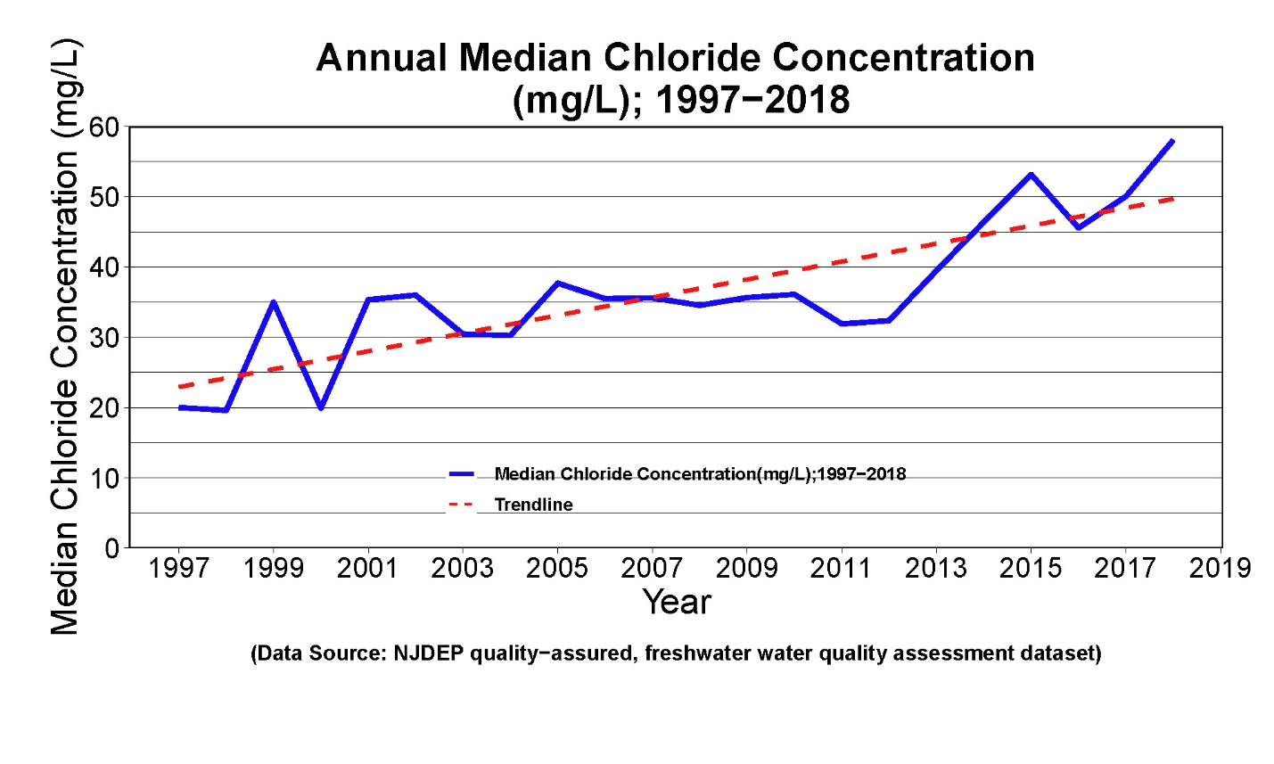

Figure 4.2: Statewide Annual Median Total Dissolved Solids Concentration from 1997 to 2018
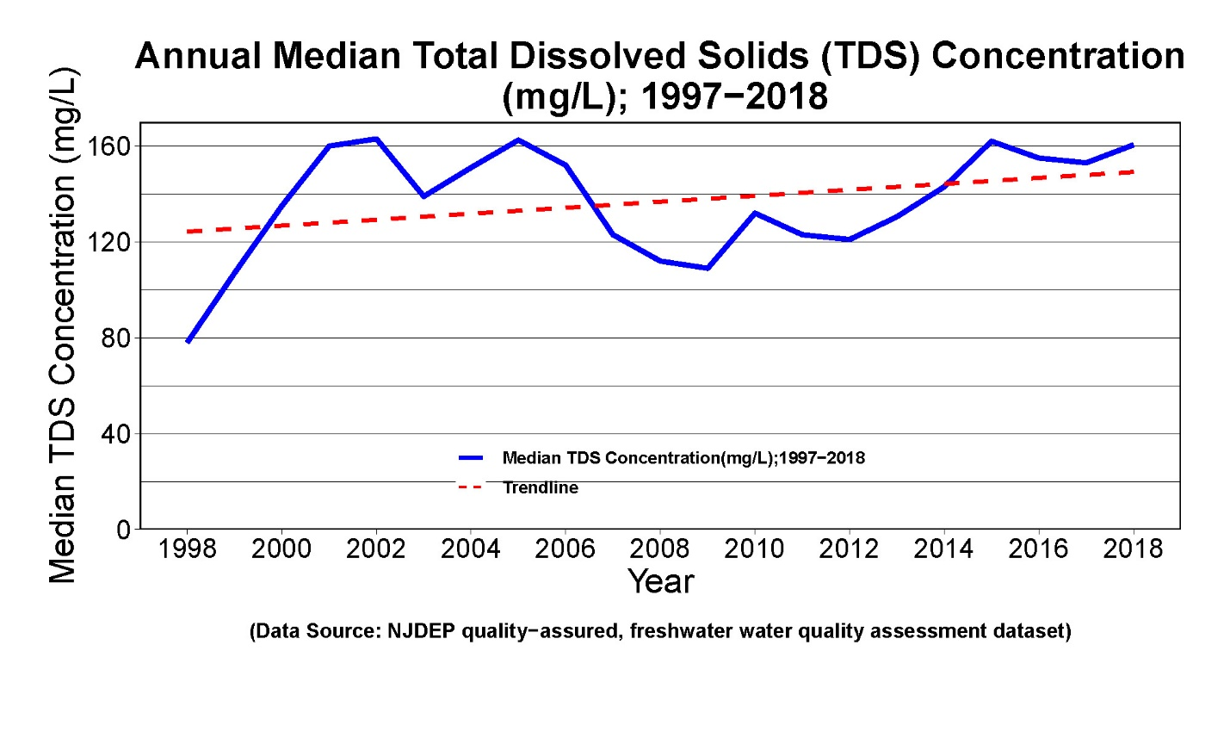
Figure 4.3: Statewide Percent of Chloride Samples over 230 mg/L from 1997 to 2018
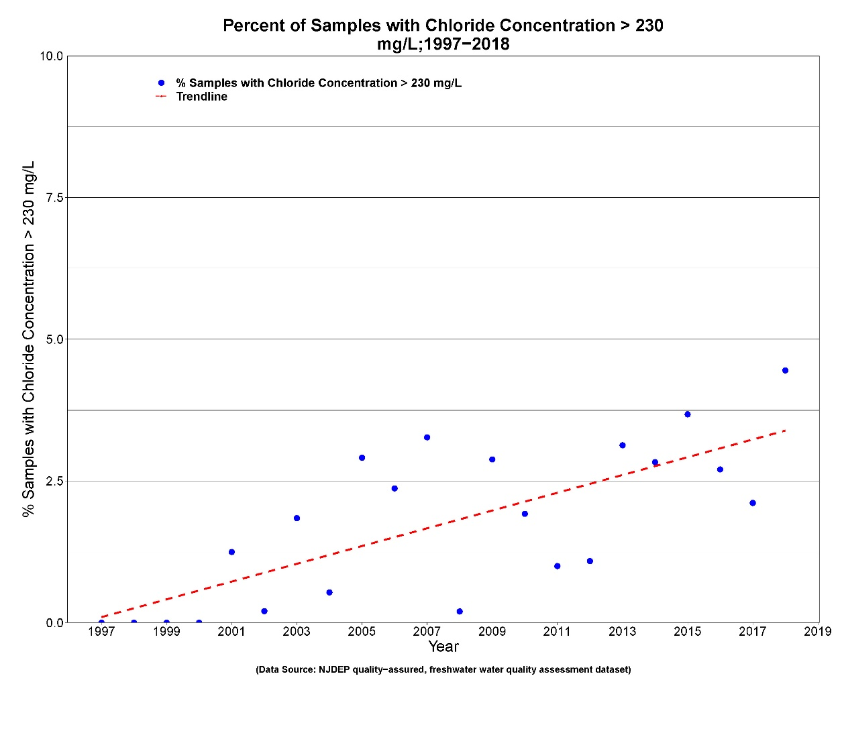

Figure 4.4: Statewide Percent of TDS Samples over 500 mg/L from 1997 to 2018
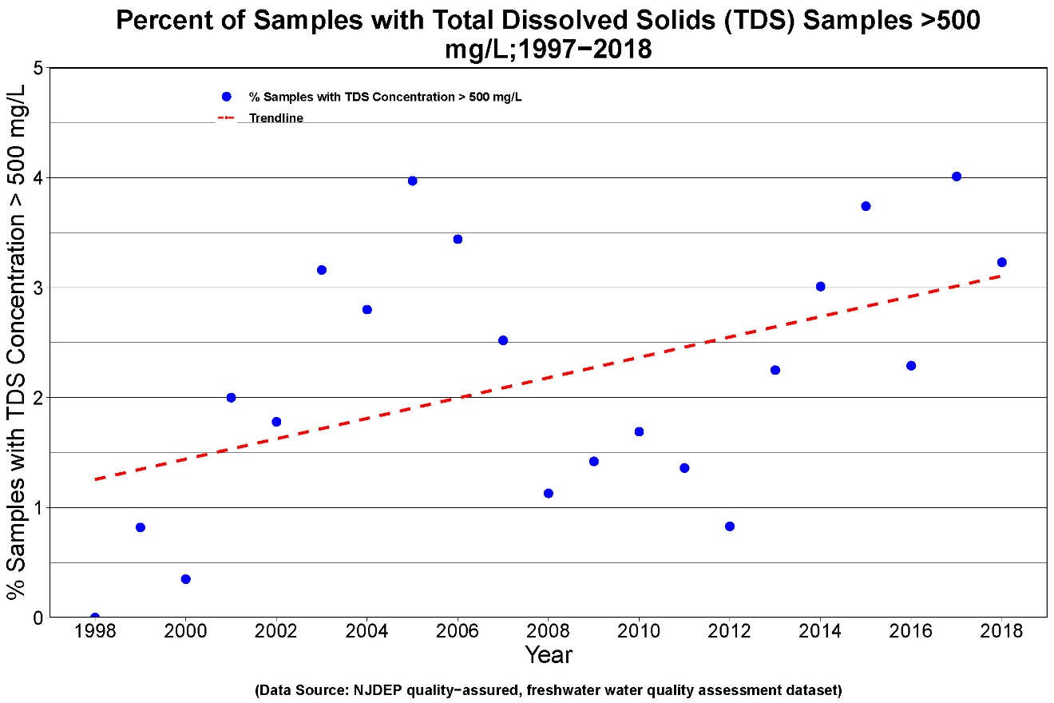
Figure 4.5: Total Dissolved Solids on the 2020 303(d) List

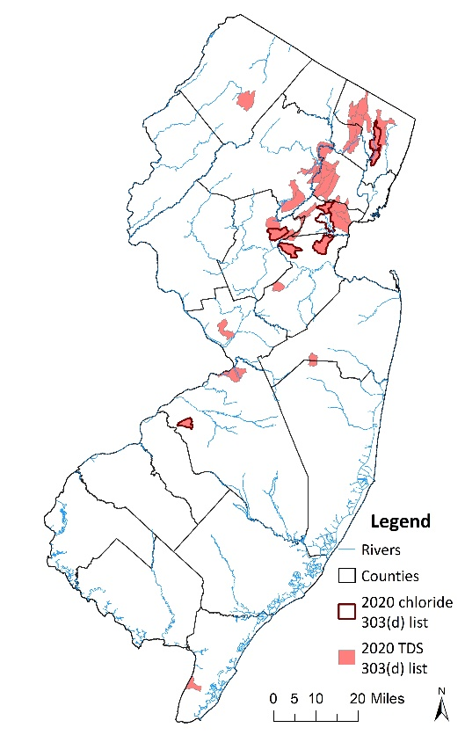
The data reviewed to develop this Integrated Report identified 39 assessment units with use impairments due to exceedances of SWQS for TDS and 8 assessment units with use impairments due to chloride (Figure 4.5). Most of the impaired assessment units are in the Piedmont physiographic region and have relatively high levels of impervious surface, although the increasing TDS and chloride trends were found in all types of land uses (urban, agricultural, mixed, and undeveloped) and physiographic regions

NJDEP Continuous Specific Conductivity Monitoring Project

More data is needed to quantify the duration and maximum values of the elevated levels in TDS and chloride and to identify the significance of road salt in the observed trends. Specific conductance (which correlates with the sum of dissolved major ion concentrations in water) is related to TDS and chloride. Specific conductance is often used as a surrogate measurement of TDS and chloride because it is easily and accurately measured in the field and supplements laboratory analytical determination of major ions, such as chloride.

Beginning in 2011, NJDEP (BFBM) deployed continuous specific conductance data loggers in a total of 41 non-tidal freshwater streams with varying levels of urbanization (Figure 4.6). During winter 2011-2012, data were collected at 5 sites, and during winter 2013-2014 data were collected at 7 sites. The project was expanded in 2016-2017 to monitor year-round at 15 sites, which included an intensive study of 11 sites in Shabakunk Creek. Continuous specific conductance monitoring is continuing at selected sites.
Figure 4.6: Continuous Specific Conductance Maximum Values

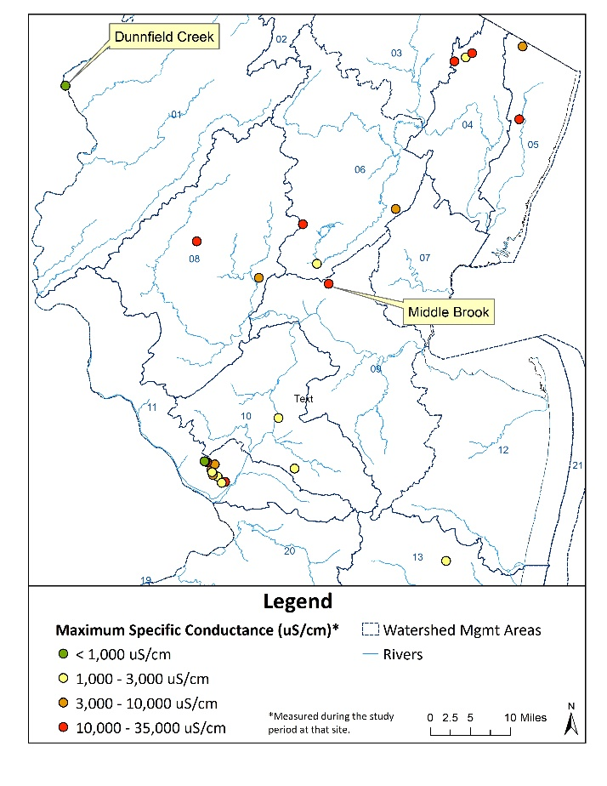
Site-specific continuous specific conductance data were graphed with weather data. Continuous specific conductance data showed substantial increases with significant snowfall events, indicative of when road salt was applied. It’s clear that typical discreet sampling cannot identify peak and duration of elevated chloride and TDS concentrations and that these elevated concentrations after winter precipitation events may be much higher than previously thought. Figure 4.7 shows one example of elevated specific conductance levels and how they are associated with precipitation events in winter months.

Figure 4.7: Example of Continuous Specific Conductance Compared to Winter Weather

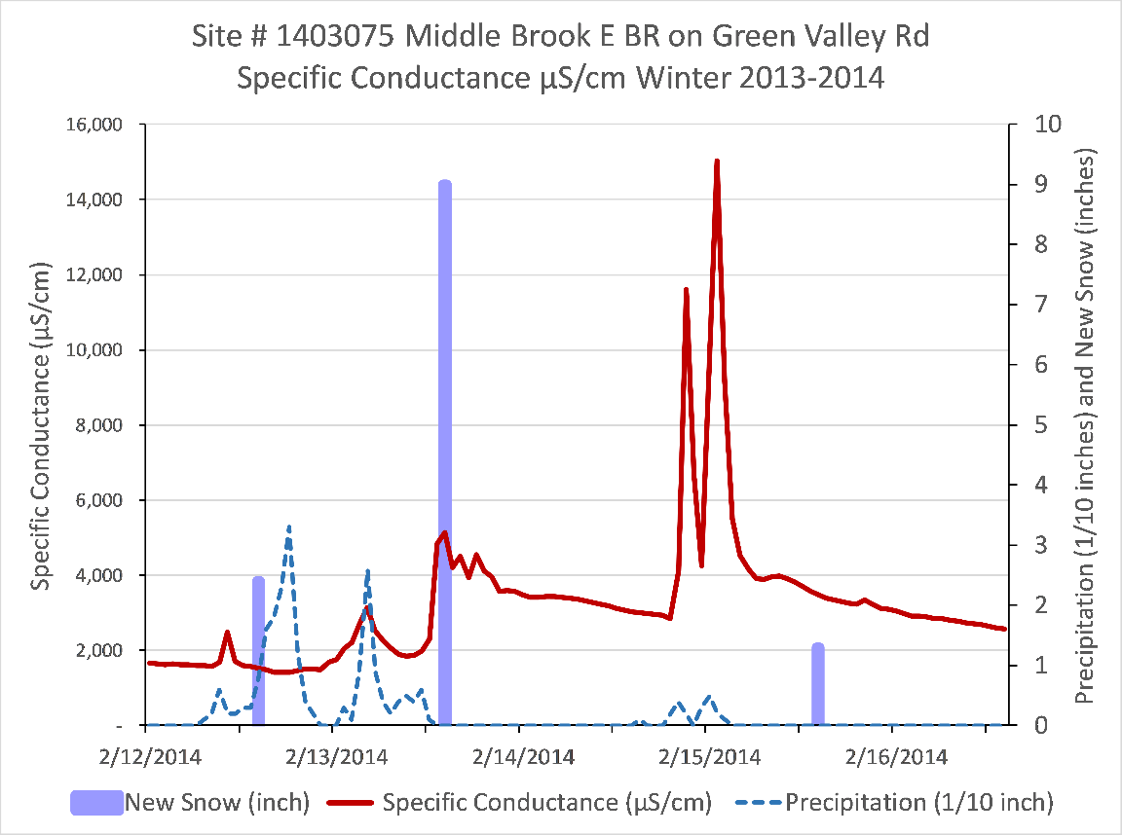

Dunnfield Creek, the reference site for this project, exhibited negligible variability in specific conductance. This assessment unit is 87% forest and only 1% urban (2012 Land Use) with almost no roads. While Dunnfield Creek fluctuated only from 27 to 34 µS/cm, more urban watersheds varied up to 33,490 µS/cm. For the 27 sites completed, mean specific conductance ranged from 31 to 4,800 µS/cm. Medians ranged from 31 to 4,400 µS/cm. Maximum values varied from 34 to 33,600 µS/cm.

Management of Road Salt Impacts

The DEP has developed required and recommended best management practices as part of its Municipal Stormwater Regulation Program to reduce the use and impact of deicing materials. Additional guidance documents are available for highway agencies., In addition, the DEP has a Snow Removal and Disposal Policy that prohibits the dumping of snow in waterbodies, wetlands, stormwater basins etc. except with an emergency permit from the DEP. A Water Quality Restoration Program grant awarded to Brick Township Municipal Utilities Authority includes tasks aimed at reducing road salt impacts, through development of a winter road de-icing best management practices report, workshop and pilot municipal demonstration project.

Correlations are being developed between specific conductance and grab samples analyzed for TDS and chloride and with land use and road characteristics. Road salt usage and loading trends are being compiled and other states’ approaches to reduce road salt impacts are under review, including TMDLs and BMPs. These efforts will inform the DEP’s technical and implementation approach to address the increasing trends in TDS and chloride concentrations and surface water impairments.

Mullaney, J, Lorenz, D. and Arntson, A. 2009. Chloride in groundwater and surface water in areas underlain by the glacial aquifer system, northern United States. U.S. Geological Survey, Scientific Investigations Report 2009–5086. Available at https://pubs.usgs.gov/sir/2009/5086/
Corsi, S., De Cicco, L., Lutz, M., Hirsch, R. 2015. River chloride trends in snow-affected urban watersheds: increasing concentrations outpace urban growth rate and are common among all seasons. Science of The Total Environment Volume 508, 1 March 2015, Pages 488-497. Available at https://doi.org/10.1016/j.scitotenv.2014.12.012
Robinson, K., Lazaro, T., Pak, C. 1996. Associations Between Water-Quality Trends in New Jersey Streams and Drainage-Basin Characteristics, 1975-86. U.S. Geological Survey, Water-Resources Investigations Report 96-4119. Available at http://pubs.usgs.gov/wri/1996/4119/report.pdf
Hickman, R. and Gray, B. 2010. Trends in the Quality of Water in New Jersey Streams, Water Years 1998-2007. U.S. Geological Survey, Scientific Investigations Report 2010-5088. Available at http://pubs.usgs.gov/sir/2010/5088/
Hay, L. and Campbell, J. 1990. Water-Quality Trends in New Jersey Streams. U.S. Geological Survey, Water-Resources Investigations Report 90-4046. Available at http://pubs.usgs.gov/wri/1990/4046/report.pdf
Hickman, R. and Barringer, T. 1999. Trends in Water Quality of New Jersey Streams, Water Years 1986-95. U.S. Geological Survey, Water-Resources Investigations Report 98-4204. Available at https://pubs.usgs.gov/wri/wri98-4204/
Hickman, R. and Hirsch, R. 2017. Trends in the Quality of Water in New Jersey Streams, Water Years 1971–2011. U.S. Geological Survey, Scientific Investigations Report 2016–5176. Prepared in cooperation with the NJDEP and the Delaware River Basin Commission. Available at https://pubs.er.usgs.gov/publication/sir20165176
Heckathorn, H. and Deetz, A. 2012. Variations in Statewide Water Quality of New Jersey, Water Years 1998-2009. U.S. Geological Survey, Scientific Investigations Report 2012-5047. Available at http://pubs.usgs.gov/sir/2012/5047/
Moore, J., Fanelli, R. and Sekellick, A. 2020. High-Frequency Data Reveal Deicing Salts Drive Elevated Specific Conductance and Chloride along with Pervasive and Frequent Exceedances of the U.S. Environmental Protection Agency Aquatic Life Criteria for Chloride in Urban Streams. Environ. Sci. Technol. 54, 2, 778–789. https://doi.org/10.1021/acs.est.9b04316
U.S. Geological Survey. 2005. “Salt end-use statistics through 2003”; last modified September 15, 2005, in Kelly, T.D., and Matos, G.R., comps., Historical statistics for mineral and material commodities in the United States (2016 version). U.S. Geological Survey Data Series 140, accessed 2/8/2021. Available at https://minerals.usgs.gov/minerals/pubs/historical-statistics/
U.S. Geological Survey. 2021. Mineral Commodity Summaries, Salt. Available at https://minerals.usgs.gov/minerals/pubs/commodity/salt/
U.S. Environmental Protection Agency. May 1973. Water Pollution and Associated Effects of Street Salting, USEPA, EPA-R2-73-257. Available at https://nepis.epa.gov/
Harned, D. 1988. Effects of highway runoff on streamflow and water quality in the Sevenmile Creek basin, a rural area in the Piedmont Province of North Carolina, July 1981 to July 1982. U.S. Geological Survey Water-Supply Paper 2329. Available at https://pubs.er.usgs.gov/publication/wsp2329
U.S. Environmental Protection Agency. 2005. National Management Measures Guidance to Control Nonpoint Source Pollution from Urban Areas. EPA-841-B-05-004. Available at https://www.epa.gov/nps/urban-runoff-national-management-measures
New Jersey’s Surface Water Quality Standards (SWQS) for TDS is 500 mg/L or no adverse effects on the aquatic biota, whichever is more stringent. The SWQS for chloride in fresh waters is 860 mg/L (acute) and 230 mg/L (chronic) for aquatic life and 250 mg/L for human health.
Granato, G. and Smith, K. 1999. Estimating Concentrations of Road-Salt Constituents in Highway-Runoff from Measurements of Specific Conductance. U.S. Geological Survey, Water Resources Investigation Report 99-4077. Available at https://pubs.er.usgs.gov/publication/wri994077
Miller, R. Bradford, W. and Peters, N. 1988. Specific Conductance: Theoretical Considerations and Application to Analytical Quality Control. U.S. Geological Survey Water-Supply Paper 2311. Available at https://pubs.usgs.gov/wsp/2311/report.pdf
NJDEP Municipal Stormwater Regulation Program. Available at https://www.nj.gov/dep/dwq/msrp_home.htm
NJDEP Highway Agency Stormwater Guidance Document. August 2004. Available at https://www.nj.gov/dep/dwq/highway_guidance.htm
NJDEP Emergency Snow Removal and Disposal Policy. December 2014. Available at https://www.state.nj.us/dep/dwq/pdf/snow_removal.pdf

