


Organization Name

Street Address
Address 2
City, ST ZIP Code

xxx-xxx-xxxx
www.agencyname.org

Put Life
Back in
Your Life



Put Life
Back in
Your Life

Feel better.

Be in control.

Do the things
you want to do.

Find out more about
TAKE CONTROL OF YOUR HEALTH Workshops.



TAKE CONTROL OF YOUR HEALTH

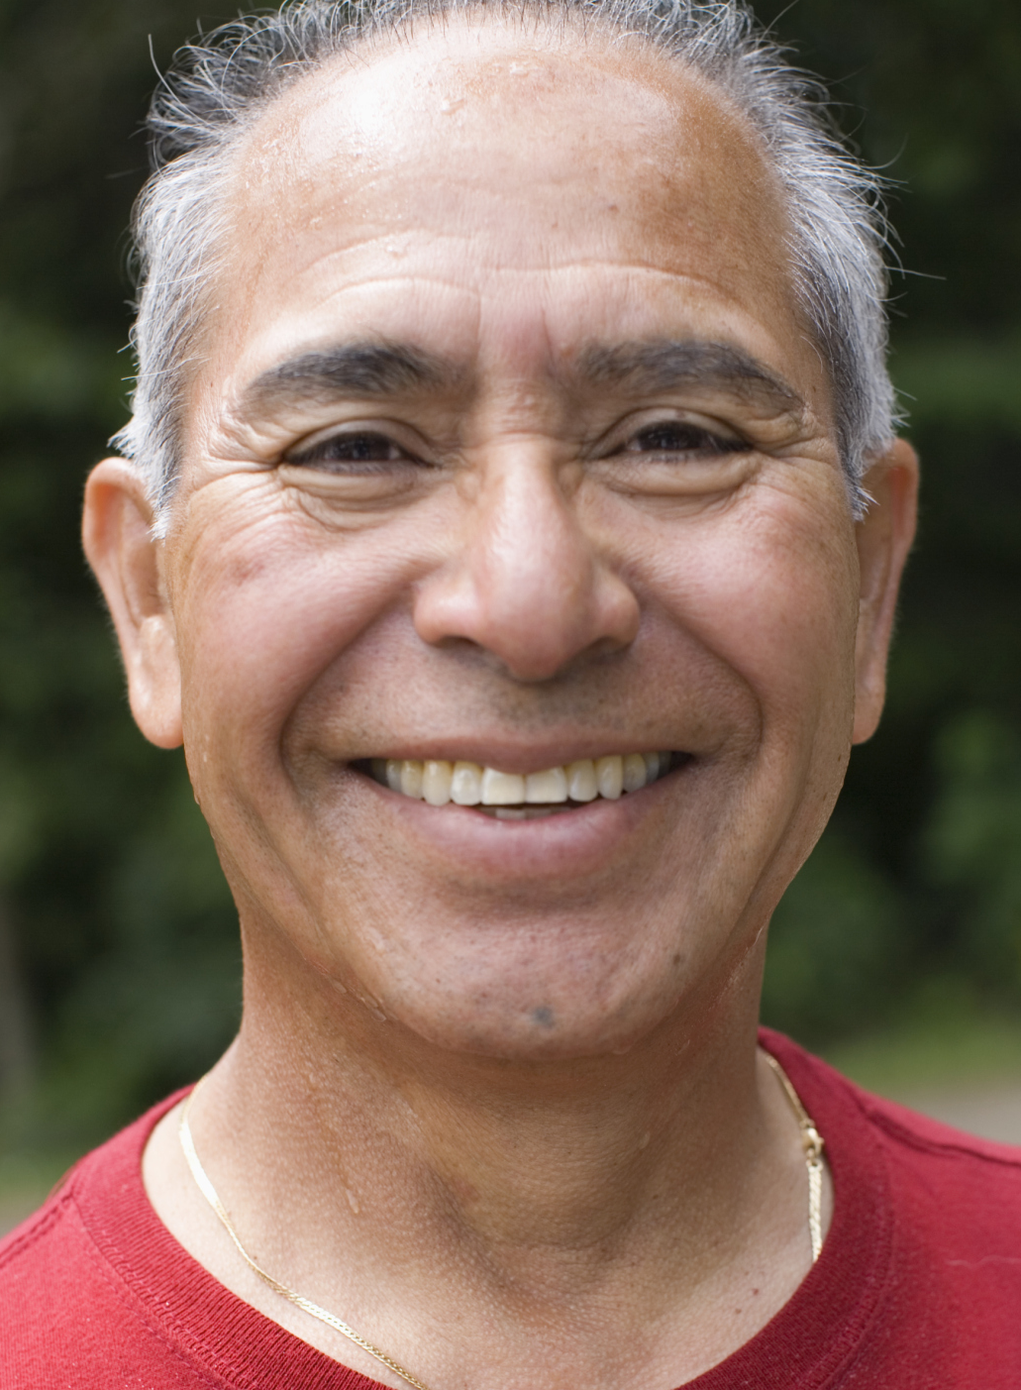



“Now I have more
energy than I’ve had in years. I’m calmer and more confident about
my health.”
“The workshops put
me back in charge of my life, and I feel
great. I only wish I had done this sooner.”
Put Life Back Into Your Life.
Consider a TAKE CONTROL OF YOUR HEALTH Workshop.

Are you an adult age 55 or older with an ongoing health condition?

You’ll get the support you need, find practical ways to deal with pain and fatigue, discover better nutrition and exercise choices, understand new treatment choices, and learn better ways to talk with your doctor and family about your health.

If you have conditions such as diabetes, arthritis, high blood pressure, heart disease, chronic pain, anxiety, the [insert your program name] Workshop can help you take charge of your life.
Sign Up Now.
Spaces Are Limited.

Join a free 2 ½-hour [insert your program name] Workshop, held each week for six weeks.

Learn from trained volunteer leaders with health conditions themselves.

Set your own goals and make a
step-by-step plan to improve your health—and your life.
To register or get more information, please call:
xxx – xxx – xxxx
“In just a few weeks, I got back to
feeling better — and back to being the kind of person I like to be.”

